UI BOOK QUEST:EXPLORING

LIBRARY JOURNEY EXPERIENCE

FOR PHINMA UI LIBRARY

A Capstone Project Presented to the Faculty of the

College of Information Technology Education PHINMA University of Iloilo

In Partial Fulfillment

of the Requirements for the Degree Bachelor of Science in Information Technology

By

Davein S. Siva

Dionard I. Antioquia

John Carmelo F. Flame

March 2025

**APPROVAL SHEET**

In partial fulfillment of the requirements for the Bachelor of Science in Information Technology, this Capstone Project entitled “UI BOOK QUEST:Exploring Library Journey Experience For PHINMA UI Library”, prepared and Submitted by Davein M. Siva, Dionard I. Antioquia and John Carmelo F. Flame who are hereby recommended for corresponding final evaluation.

**Nicole D. Lampa**

Adviser

Approved by the Panel of Evaluators with a grade of PASSED

**Dr. Arnold M. Fuentes, Ph. D, MPA, MMIT**

Chair Panelist

Accepted in partial fulfillment of the requirements of the degree Bachelor of Science in Information Technology

**Seth dA. Nono, MSCS**

CITE, Dean of Deans

**ACKNOWLEDGEMENT**

First and foremost, We would like to express our gratitude to God Almighty for guiding us throughout the journey of this project.

The proponents wish to extend our gratitude to PHINMA University of Iloilo Library for generously providing the essential data required for our project’s data gathering process.

We would like to express our gratitude and thanks to Miss Nicole D. Lampa, Research Adviser of CITE Department. The proponent is deeply grateful and indebted for the expert,sincere, and invaluable guidance and encouragement extended to them.

We would also like to extend our thanks to Mr. Ryan C. Valeriano, Capstone Adviser of CITE Department, for his unwavering commitment to educating and guiding us throughout this project.

The proponent takes this opportunity to give thanks to all the faculty members of CITE department for their willingness to help and encouragement their continuing assistance is such a big help to complete this project.

**DAVEIN M. SIVA**

**DIONARD I. ANTIOQUIA**

**JOHN CARMELO F. FLAME**

**ABSTRACT**

The "UI BOOK QUEST: EXPLORING LIBRARY JOURNEY EXPERIENCE FOR PHINMA UI LIBRARY" highlights the need for an interactive platform to improve book selection processes and gather user feedback efficiently. Traditional library systems often lack tools for effective user engagement, leading to inconsistent reading experiences and challenges in understanding user preferences.

This online web-app platform provides a solution by allowing people to submit insightful book evaluations and track attendance. Users' interactions make them feel more a part of the library, and administrators get important information about the preferences of users. It encourages relationships and makes everyone's time in the library more enjoyable.

By leveraging attendance records and user feedback, library administrators can make informed decisions about book acquisitions and curating collections. This abstract highlights the platform's potential to revolutionize library interactions and enrich the reading experience in an increasingly digital landscape.

**TABLE OF CONTENTS**

Page

Title page ----------------------------------------------i

# Certificate of Authorship -------------------------------ii

Approval Sheet -----------------------------------------iii

Acknowledgement ----------------------------------------iv

Abstract ------------------------------------------------v

Table of Contents --------------------------------------vi

List of Figures ---------------------------------------vii

List of Tables ----------------------------------------viii

**CHAPTER I**

INTRODUCTION--------------------------------------------------#

Background of the Study -------------------------------#

Purpose and Description of the project ----------------#

Statement of the Problem ------------------------------#

General Objectives -------------------------------#

Specific Objectives ------------------------------#

Project Scope -----------------------------------------#

Limitation of the Project ------------------------#

Significance of the Study ------------------------------#

**CHAPTER II**

RELATED LITERATURE AND STUDIES -------------------------------#

Topic 1 ---------------------------------------------------#

Topic 2 -------------------------------------------------#

**CHAPTER III**

TECHNICAL BACKGROUND -----------------------------------------#

**CHAPTER IV**

DESIGN AND METHODOLOGY--------------------------------------#

Context Diagram / Diagram 0 -----------------------------#

Analysis and Design -----“ UML or ER Diagrams”-------------#

Development Method ------------“Model to use”-#

Software Development tools ---------------------------#

Project Management -----------------------------------#

Schedule and timeline-------“Grant chart”--------#

Tangible Benefits ------------------------------------#

Intangible Benefits ----------------------------------#

Project Cost -----------------------------------------#

Return Of Investment ---------------------------------#

**CHAPTER V**

System Analysis------------------------------------------#

The Proposed System ----------------------------------#

Features of the System -------------------------------#

Software and Hardware Requirements -------------------#

Software and Hardware Specification ------------------#

DFD --------------------------------------------------#

Child Diagram ----------------------------------------#

Data Element -----------------------------------------#

Data Store -------------------------------------------#

**CHAPTER VI**

Conclusion and Recommendations -----------------------------#

SUMMARY OF FINDINGS ----------------------------------#

Conclusion -------------------------------------------#

Recommendations --------------------------------------#

REFERENCES -------------------------------------------#

**CHAPTER VII**

Glossary----------------------------------------------------#

**CHAPTER VIII**

APPENDICES -------------------------------------------------#

Screenshots -------------------------------------------#

Source Code -------------------------------------------#

Users Guide -------------------------------------------#

Curriculum Vitae --------------------------------------#

Grammarian---------------------------------------------#

**LIST OF TABLES**

**PAGE**

**TABLE 1.-------------------------------------------------#**

**TABLE 2.-------------------------------------------------#**

**TABLE 3.-------------------------------------------------#**

**TABLE 4.-------------------------------------------------#**

**TABLE 5.-------------------------------------------------#**

**TABLE 6.-------------------------------------------------#**

**TABLE 7.-------------------------------------------------#**

**TABLE 8.-------------------------------------------------#**

**CHAPTER I**

**INTRODUCTION**

As we are aware of the fact that our lives are becoming very fast every day. Technology is the most important factor that helps us make human life easier. Technology alone can do the work of hundreds, even thousands of people. At the same time, technology performs computational work efficiently and accurately. As technology innovates and expands today. Many institutions and companies are improving their systems, especially for libraries.

Academic libraries in particular and libraries in general are affected significantly by technology, which is also feeding rising user expectations for quick delivery of information resources. nonetheless, the effects of evolving technology. Helping students and others understand how to utilize the new technology to get information is one of the library's expanding responsibilities.

As a result, libraries are required to provide more often, which calls for the provision of a fully working system. increasingly space must be allocated for this purpose as the library's instructional role becomes increasingly crucial, thanks in large part to the arrival of technology.

The word library is derived from the old French term “bibliothèque”, which means "a collection of books". Reading materials in school are stored in libraries. A library is a place in which books and related material are kept for use, not for sale. It is also organized for use and maintained by a public authority, an institution, or a private individual. In addition, it is a place where we can get information in any format and from many sources. The librarian must keep the room clean so that it is conducive to learning. The librarian is also the person who is responsible for monitoring the library user attendance and all the book reviews and recommendations from the book they read.

The UI-PHINMA Library needs a project collecting user feedback and reviews generated by them, and providing personalized recommendations or suggestions based on their input or feedback. This process helps users in discovering books, services, or content that match their interests and preferences. It uses data collection, analysis, and algorithmic decision making to enhance the overall user experience.

Additionally, this project includes Online Attendance Analytics Dashboard managing and organizing attendance records. This is a efficient way to track and maintain records of library users attendance.

**BACKGROUND OF THE STUDY**

In the dynamic world of library and information services, a pressing necessity arises for an interactive and efficient approach to gather library attendance and user feedback, and enhance book curation.

Traditional library systems frequently lack the resources needed to gather library users' attendance and effectively use feedback, which leads to inconsistent reading experiences. Due to this restriction, the library is unable to assess the popularity and usefulness of the books in its collection, making it challenging to select works that suit user preferences.

Individuals may post book reviews, rate books, express their opinions, library administrators using a user-friendly internet interface. A lively and collaborative literary environment is created as a result. Users may utilize the reviews and recommendations from the book they’ve read and to request specific resources, or offer recommendations, which helps the library become more responsive and user centered.

Library administrators can gather valuable information from user comments and direct interactions within the review and recommendation form. This data-driven approach facilitates informed decision-making regarding book purchasing and collection management. By responding to readers' interests and meeting their specific needs, libraries ensure a diverse and attractive collection. Additionally, leveraging this information allows administrators to personalize the library experience based on customer preferences. This system streamlines processes and creates a seamless experience for users and library staff.

In summary, the library of using an online web library will be enriched by the addition of an online attendance system, feedback and reviews. This modern approach to library services in the digital age not only enhances the user experience and promotes literary discovery, but also establishes a robust and responsive channel of communication between customers and library administrators. As libraries adapt to the challenges and opportunities brought by digital advancements, this web-based solution emerges as a powerful tool to optimize library services and promote awareness and stronger community among users.

**PURPOSE AND DESCRIPTION OF THE PROJECT**

The proposed system aims to transform library services by introducing a digital advanced platform. This platform seeks to enhance library services, streamline online attendance tracking, optimize collection management.

This comprehensive project includes a feedback system where users can submit reviews and share opinions. To make the reading experience better, the recommendation system uses user feedback to provide personalized book recommendations.

Utilizing data analytic technologies, useful data is retrieved to guide library decision-making. Ultimately, the study aims to create a dynamic and user-centered library environment by bridging the gap between users and administrators, optimizing library services and strengthening public awareness and community in the library.

**STATEMENT OF THE PROBLEM**

In today's generation, students of the University of Iloilo are the commonly library users that can benefit the services and the books provided by the library, The traditional model of library service may not fully satisfy if the books that the library users finished reading can’t give their valuable insights and interactions that can enhance their reading experience.

The library currently relies on a manual attendance system, which has presented significant challenges for library users. One of the primary issues is the formation of long queues, leading to extended waiting times for library users to submit their attendance. This also consumes valuable time that could otherwise be spent on productive library activities.

The manual attendance system may result in inefficiencies in data management and retrieval. it requires library staff to dedicate substantial time and effort to record and organize attendance data manually, which can be a resource intensive process. Additionally, the potential for human errors in data entry and management poses further concerns.

Library users miss their opportunities to reflect on the books they've borrowed or read within the library, limiting the ability to share feedback and recommendations. Additionally, librarians, who are guiding readers to recommend some books to discover, may not have a simplified process to collect and utilize user feedback effectively.

**GENERAL OBJECTIVES**

Our goal is to create an online website that allows library staff to manage and record library users' attendance efficiently,In Addition library users can share their insights,reflection, and book recommendations to enhance the future book selections inside the library.

**SPECIFIC OBJECTIVES**

This project aims to develop an website that will:

1.Facilitate Library Attendance:Enable library staff to efficiently record and manage attendance,reducing waiting times queues for library users while ensuring accurate attendance records.

1. Feedback and Recommendations:Where users can share their insights,reflections, and book recommendations to improve future library book selections.

3.User reviews: Provide users with the ability to access and explore reviews submitted by other users. This feature will help other library users to make informed choices when selecting books, fostering a more engaging and enriched reading experience.

4.User-Friendly Reporting interface: Ensure the interface is accessible and user-friendly for students, teachers and Library administrators.

**PROJECT SCOPE**

The “UI BOOK QUEST: Exploring Library Journey Experience for UI-PHINMA Library” is a web-based application using the languages HTML, PHP and Bootstrap. Its main aim is to streamline and enhance efficiency of library attendance recording and management. This system aims to simplify the attendance process for library users, reducing the need for manual data entry, enhancing data accuracy and improving library services.

**LIMITATION OF THE SYSTEM**

The system requires internet connection, mobile device or computer.

Collecting and storing data for personal privacy concerns. Ensuring compliance with data protection regulations and addressing user privacy concerns is important.

The system will be only convenient for the students and employees of PHINMA University of Iloilo.

**SIGNIFICANCE OF THE PROJECT**

1.Library staff: This study will help the library staff, who is responsible for recording and managing the library attendance in the fastest way.

1. Library administrators: This study will provide support to the library administrators to easily access all attendance records, with this enhanced accessibility, they will be able to conduct thorough and efficient data analysis.

3.University of Iloilo PHINMA: This study would greatly benefit the institution by encouraging the school to adopt and develop the system for the benefit of the students.

**CHAPTER II**

**REVIEW AND RELATED LITERATURE**

In as much as the library plays a crucial role in the support to University programs. This chapter will discuss some of the major differences between the researchers proposed system and another existing library management system. This involves the systematic identification, location, and analysis of documents containing information related to research problems. The term is also used to describe the written component of a research plan or report that discusses the reviewed documents.

The Library is considered as the intellectual center of academic excellence a place for study and research plays a huge role in the lives of the students. Library services availed by library users need to be more efficient and effective.

Provides essential information and resources that supports the curricular programs of the University (PHINMA UI Library Manual,2023)

Students’ experience must be excellent and worth staying once more.

Based on the concept from Priestner and Matt Borg,2016 stated that today’s library services are incredibly complex. Long gone are the days when librarians were only questioning how to arrange their stock and have it circulate appropriately among their users. Now we also grapple with striking the right balance between print and electronic media, seamlessly serving both physical and remote users, actively embracing technology and research data, and delivering effective teaching and learning. The list goes on, it is only getting longer and rarely, if ever, is anything removed from it. For every new service we offer, we have to consider how it will be implemented, to whom it will be promoted, and from where it will be accessed. In most cases, this means considering myriad approaches, time consuming tailoring of messages for different platforms and users, and offering a variety of alternative delivery methods.

To make the experience of every library user, the necessity to offer varied resources and comfortable search engines must be provided.

Libraries worldwide are now embracing varied approaches by the use of technology not setting aside the print resources.

Locally, many libraries in the Philippines, specifically in Iloilo City are in the trend by the use of both print and non-print resources (e-resources) to suffice the craving needs of library users. Serving them in a varied way may fulfill their needs for research.

Rhia Granna, 2022 states that Libraries need to innovate in order to survive and stay relevant amid the changing times.

PHINMA UI Library needs better and improved services for students to have a more meaningful experience.

It is believed that a will equipped and managed library has a better service and makes library user experience to a maximum level.

**TECHNICAL BACKGROUND**

**3.1 Introduction**

This chapter offers a detailed exploration of the technologies that drive our library web application. Web Development has seen remarkable advancements, incorporating state-of-the-art hardware and software. Understanding the present web application is developing robust and scalable online solutions.

**3.2 Technicality of the project**

The proponents have used a Web-based Library Journey Experience wherein the users can access it through digital platforms. UI Book Quest: Exploring new and exciting book recommendations and discovering hidden gems is a digital platform for users to provide insightful feedback and ratings for borrowed books, creating a community-driven literary space and enhancing the library experience. These are some of the technical terms that are being used in our project:VSCode,PHP,HTML,CSS,Apache,Database(XAMPP),and PhpMyAdmin. Some of the terminologies stated above are also the technologies being used in our project.

**3.3 Software**

This project will be available on any technology, such as mobile phones, laptop and computers, to run the system.

**VS Code** - In the development of the system, using Visual Studio Code for encoding the source code of the system is necessary in order to be accurate with the system.

**PHP** - is a general-purpose scripting language that is especially suitable for server-side web development, where PHP generally runs on the server.

**XAMPP** - Developers use this as a development tool to allow website designers to test their work on their own computers.

**MySQL** - is a tool used to manage databases and servers that is used by developers.

**Apache** - is the Apache HTTP server that processes requests and serves web assets and content.

**HTML** - is the language used to create web pages and display browsers.

**CSS** – style sheets are used to format the layout of web pages. They can use text style, table size, and other aspects of the web pages to help the developer create a uniform website.

**Bootstrap** - Designed to enable responsive development of mobile-first websites, Bootstrap provides a collection of syntax for template designs.

**3.4 Hardware**

The hardware specifications for our project include:

Server: We host our library web application on a dedicated server with the following specifications:

Processor: [Intel® Core™ i3 processor 14100 (12M Cache, up to 4.70 GHz)](https://www.intel.com/content/www/us/en/products/sku/236774/intel-core-i3-processor-14100-12m-cache-up-to-4-70-ghz/specifications.html)

RAM: 8.00GB RAM

Storage: 512 GB

Operating System: Windows 11 Home Single Language 64-bit(10.0, Build 22621)

System Manufacturer: Lenovo COMPUTER INC.

BIOS: X415MA.302

Chip Type: Inter(R) UHD Graphics Family

Device Type: Full Display Device

Client Devices: Our web application is designed to be compatible with various client devices, including:

Mobile Phones

Laptops

Computers

Tablets

These hardware components collectively support the efficient functioning and accessibility of our library web application across diverse platforms.

**CHAPTER IV**

**DESIGN AND METHODOLOGY**

In this method Agile model is used to show the process of how the system was designed. This model is divided into six different phases going one at a time, the output of one phase being used as the input of the next phase. Every phase must be completed before the next phase starts and the phases cannot overlap. There is no going back to a previous phase once that phase is finished.

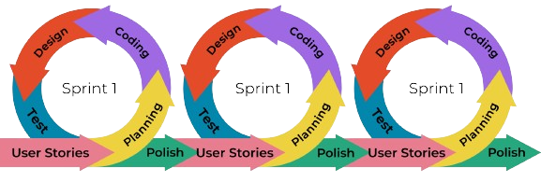

**Figure 1:** Agile Process

* **Embarking on the Adventure - Sprint:**

With our preparations complete, we set out on our sprint towards success. Guided by our roadmap and fueled by our passion, we embark on a series of sprints, each one bringing us closer to our goal of sharing UI Book Quest with the UI-PHINMA.

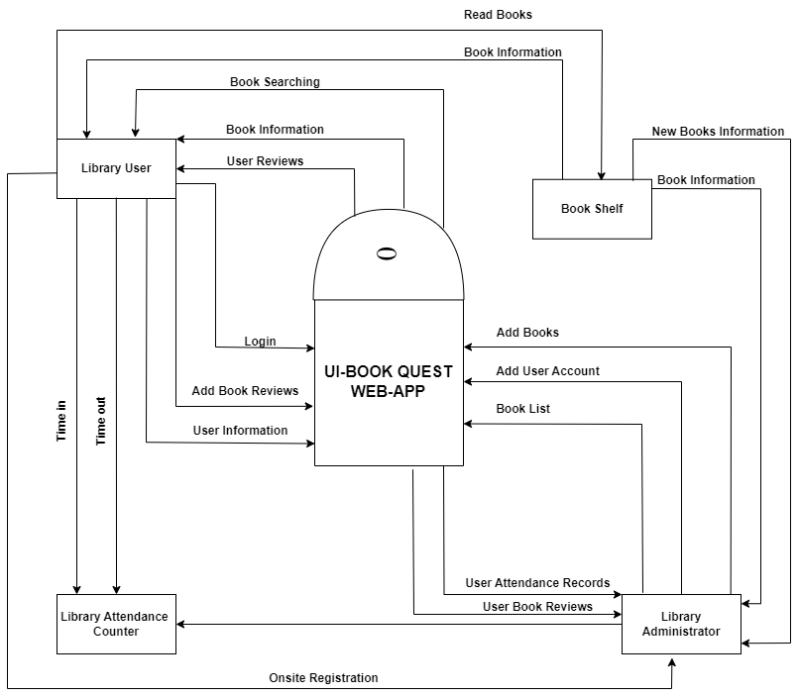 **Figure 3**: Context-diagram

The context diagram illustrates how outside parties engage with our web application, in a representation. The web application relies on four entities for its operation;

1. **Library Administrators**: These individuals oversee the operation of the library platform. With system access they manage user accounts, moderate content and configure system settings.

1. **Library Attendance Tracker**: Responsible, for monitoring and maintaining records of library attendance ensuring tracking of people entering and exiting the library. This process helps in the library facility management and resource allocation.
2. **Book Shelf**: The Book Shelf entity serves as the digital repository of books available within the library's collection. It serves two purposes:

For Library Users: It provides users to browse and explore the library's collection of books, facilitating access to reading materials and literary exploration.

For Library Administrators: It enables administrators to view newly added books to the library collection, allowing them to stay updated on inventory changes.

1. **Library Users:** Library Users are the primary individuals who utilize our web-application. This includes students, faculty, and employees who frequently visit the library. They are the ones who benefit the most from the system. Whether they're searching for books, studying, or simply reading, Library Users can submit reviews, watch reviews, and take their library attendance. Their active participation helps us improve the library experience for everyone.

**Analysis and Design**

In the analysis and design phase, we gather and examine requirements in order to plan the functionality of the system. Entity-Relationship Diagrams are used in database design to ensure that the structure is well-organized and functional.  
  
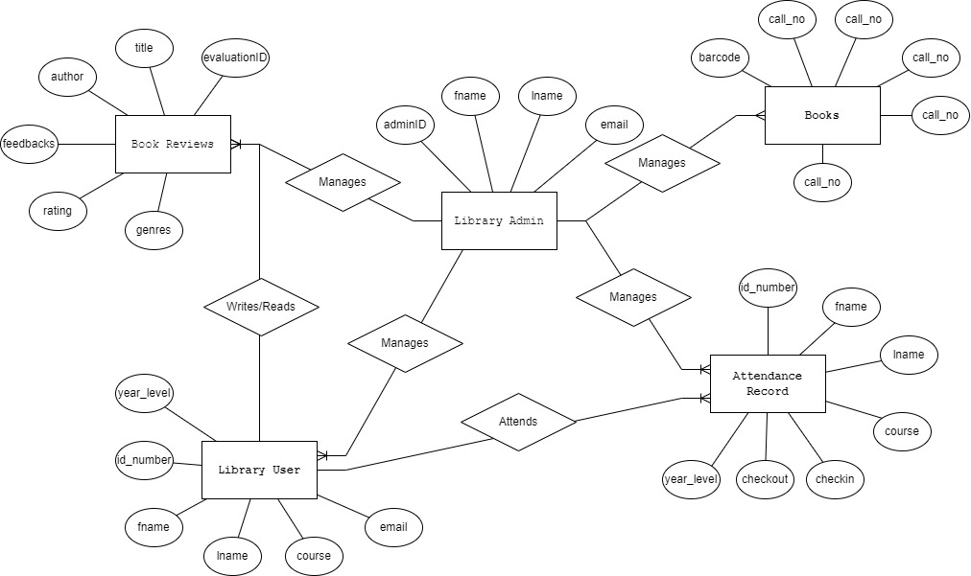

**Figure 4**: Entity-Relationship Diagram

Entity-Relationship Diagram (ERD) is an essential tool for improving stakeholder understanding and communication. For developers working on the project's database, the ERD acts as a guide by providing a visual representation of the relationships and database structure. It helps to make system functionalities and needs more clear, which eventually results in more effective and efficient system development.  
  
1.Library Administrator: The Library Administrator is incharge of supervising of the digital platform of the library acts as the foundation of our proposed web-application. They manage the following four key entities.

1. Books: The library books serves as a source of knowledge.  
   The library administrators makes sure that the books in the web-application are organized and maintained.
2. Library Users: Library users are the main characters in our library community they are capable of exploring and experiencing a lot of literature. They are welcome to access the library resources and experience more engagement with the web application.
3. Attendance Record:Tracking library attendance is important for monitoring attendance behavior in the library.  
   The library administrator maintains accurate attendance records.

**Development Method** In this method Agile model is used to show the process of how the system was designed. This model is divided into six different phases going one at a time, the output of one phase being used as the input of the next phase. Every phase must be completed before the next phase starts and the phases cannot overlap. There is no going back to a previous phase once that phase is finished.

* **Gathering Stories - User Stories:**

We start by listening to the stories shared by students, librarians, and book lovers at PHINMA UI Library. These stories are the heart of our project, helping us understand what our audience needs and wants.

* **Planning the Journey - Planning:**

With these stories in hand, we map out our adventure. We break down each tale into manageable tasks, creating a roadmap to guide us through the development journey.

* **Bringing Stories to Life - Coding:**

Inspired by our roadmap, we begin to breathe life into these tales through code. Our team of storytellers-turned-coders works tirelessly, transforming ideas into a digital reality that forms the landscape of UI Book Quest.

* **Painting the Picture - Design:**

As the code begins to take shape, we shift our focus to creating a visual masterpiece. Our designers work their magic, crafting an immersive and visually stunning experience for users to explore.

* **Ensuring a Smooth Ride - Testing:**

Before inviting others to join our adventure, we ensure the path is clear and obstacles are few. Our dedicated team tests every aspect of our project, ensuring a smooth and enjoyable experience for all who embark on our journey.

* **Adding the Final Touches - Polish:**

With our journey nearing its end, we take a moment to add the finishing touches. We refine every detail, enhancing the user experience to create a product that sparkles like a precious gem.

* **Embarking on the Adventure - Sprint:**

With our preparations complete, we set out on our sprint towards success. Guided by our roadmap and fueled by our passion, we embark on a series of sprints, each one

**Software Development tools**

We seek the key software tools need to make the UI Book Quest project a reality in the software development tools section. From idea to implementation, these tools are key to the project life cycle at every stage.   
  
**VS Code** - In the development of the system, using Visual Studio Code for encoding the source code of the system is necessary in order to be accurate with the system.

**PHP** - is a general-purpose scripting language that is especially suitable for server-side web development, where PHP generally runs on the server.

**XAMPP** - Developers use this as a development tool to allow website designers to test their work on their own computers.

**MySQL** - is a tool used to manage databases and servers that is used by developers.

**Apache** - is the Apache HTTP server that processes requests and serves web assets and content.

**HTML** - is the language used to create web pages and display browsers.

**CSS** – style sheets are used to format the layout of web pages. They can use text style, table size, and other aspects of the web pages to help the developer create a uniform website.

**Bootstrap** - Designed to enable responsive development of mobile-first websites, Bootstrap provides a collection of syntax for template designs.

**Table 1**: Gantt Chart

**TANGIBLE BENEFITS**

Tangible benefits are those that can be physically experienced and quantified in monetary terms. They represent measurable returns that investors can observe immediately after making an investment. Below are the tangible benefits derived from the web-application.

|  |  |
| --- | --- |
| **Estimated tangible benefits** | **Amount** |
| Reduced Paper Usage | P 5,000 |
| Folders | P 3,000 |
| Printing | P 4,000 |
| Ball pen | P 3,000 |
| Total tangible benefits | P 17,000 |

**INTANGIBLE BENEFITS**

Intangible benefits refer to advantages that cannot be directly touched or quantified in monetary terms. While they lack a tangible value, they hold considerable importance in influencing the quality of library services and experiences.

These are the following intangible benefits:

* Library user’s will no longer have long queue lines.
* It is easy for the user to express their insights after they read a book.
* They will no longer gather attendance manually.
* They can consistently gather and analyze data of the attendance record.
* The user can search books online without going in the library.
* Through automated reminders users can stay updated on upcoming events and library announcements, enhancing their overall engagement with the library community.
* Users can provide feedback directly through the platform.

**Project Cost**

|  |  |
| --- | --- |
| 2 Laptops | P 70, 000.00 |
| Internet | P 25, 000.00 |
| Mobile phone | P 30, 000.00 |
| Mobile Data | P 5,000.00 |
| Project Cost | P 12, 000.00 |
| Total | P 142, 000.00 |

**RETURN OF INVESTMENT**

**ROI = Total Benefits - Total Cost/Total Cost x 100**

**CHAPTER V**